CMNS is an outreach ministry of Central United Methodist Church.

March 2019

From the Office:

Class lists for the 2019-2020 School Year were posted on February 22. We still have some openings in the 2’s AM, 2’s PM, 3’s T/Th AM, 3’s MWF PM, 4’s MWF AM, 4’s MWF PM and 4’s M-F AM classes.

Calendar

March 7 Annual Spaghetti Dinner
March 16 Saturday Parent Workday

Important Phone Numbers

School Office: 462-5127
Church Office: 466-5046

Tax ID Number for CMNS:
94-1294904

Spaghetti Dinner

When: Thursday, March 7
Where: CMNS Fellowship Hall
Time: 5:00 – 7:00 PM

$30.00 Family of Four
$8.00 Additional Meal

Dinner includes Italian Chicken, Spaghetti, Salad and Bread
Also available:
- Dine In (tickets preordered)
- Craft activities for the children.
Don’t forget to bring money for our dessert bar, silent auction, raffle and photos of the children.
CMNS Website
Please visit:
www.centralmethodistnurseryschool.com
to find the Nursery School Handbook,
Small Street Journal, school calendar, special events and email addresses for the CMNS staff.

REMEMBER

Each family is asked to actively participate in:
- A Saturday Workday
- A Fundraiser
See bulletin board for dates and times.

Dine Out for CMNS

Join us this month at:

Our
Spaghetti Dinner!

Thursday
March 7
5:00-7:00 PM

Sign Ups for Summer Camp will be available on a first come first serve basis during the months of March through May. All currently enrolled students who can use the bathroom independently and Alumni Kindergarten and First Grade students can attend. Incoming 3 and 4 year-olds who are enrolled in the fall with all of the necessary paperwork completed are also eligible.

Session 1 June 04 – June 13
(Looking for Treasure)
Session 2 June 18 – June 27
(Lost in Space)
Session 3 July 09-July 18
(Jungle Fun)
Session 4 July 23 – August 1
(Let’s Get Physical)

- All camps run from 8:30-11:30 AM
- Tuesday through Thursday
- Two Week Sessions
- Cost per session: $130
- Children bring their own snack
- Please note: there are no classes the week of July 1st

Artwork submitted by Ms. Barbie and Ms. Kellie’s 3’s MWF AM class.

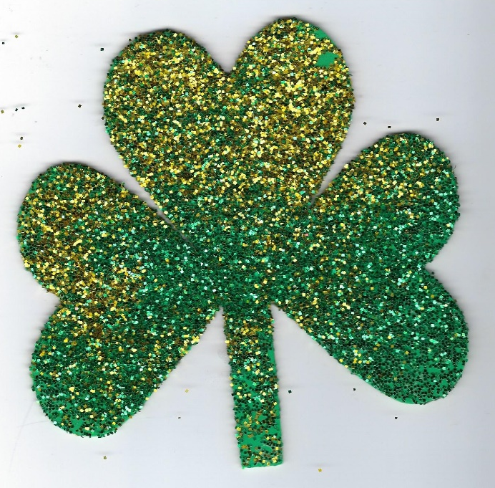

Allen

Ella

Maddison

Mark

